3.7 I can select and join networks and data feeds to manage data to suit collaborative tasks

I regularly join mailing lists based on my interests. For example, I have subscribed to updates from a website called Future Learn who email me updates on new courses, as well as courses I have added to my wish list, screen shot below;

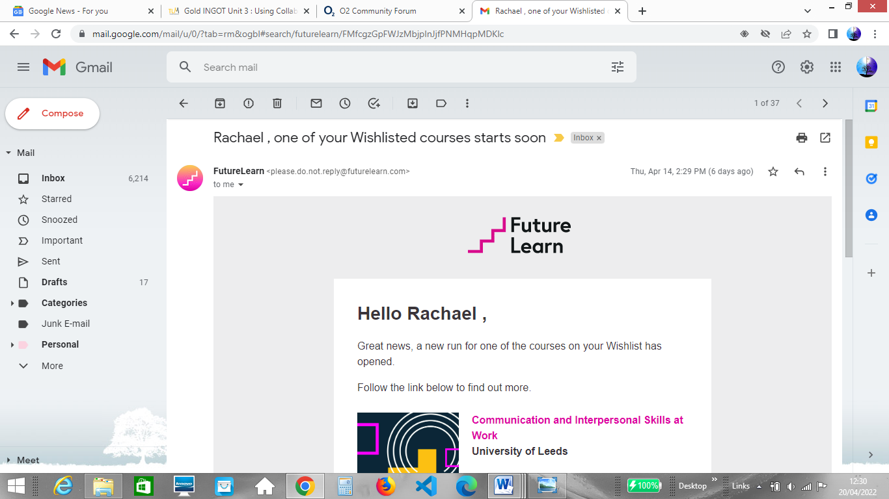

Occasionally I will use forums to ask questions. For example, I recently had an issue with my mobile phone contract so I used the mobile phone provider’s community forum to see if anyone could help give an answer to my question as evidenced below;

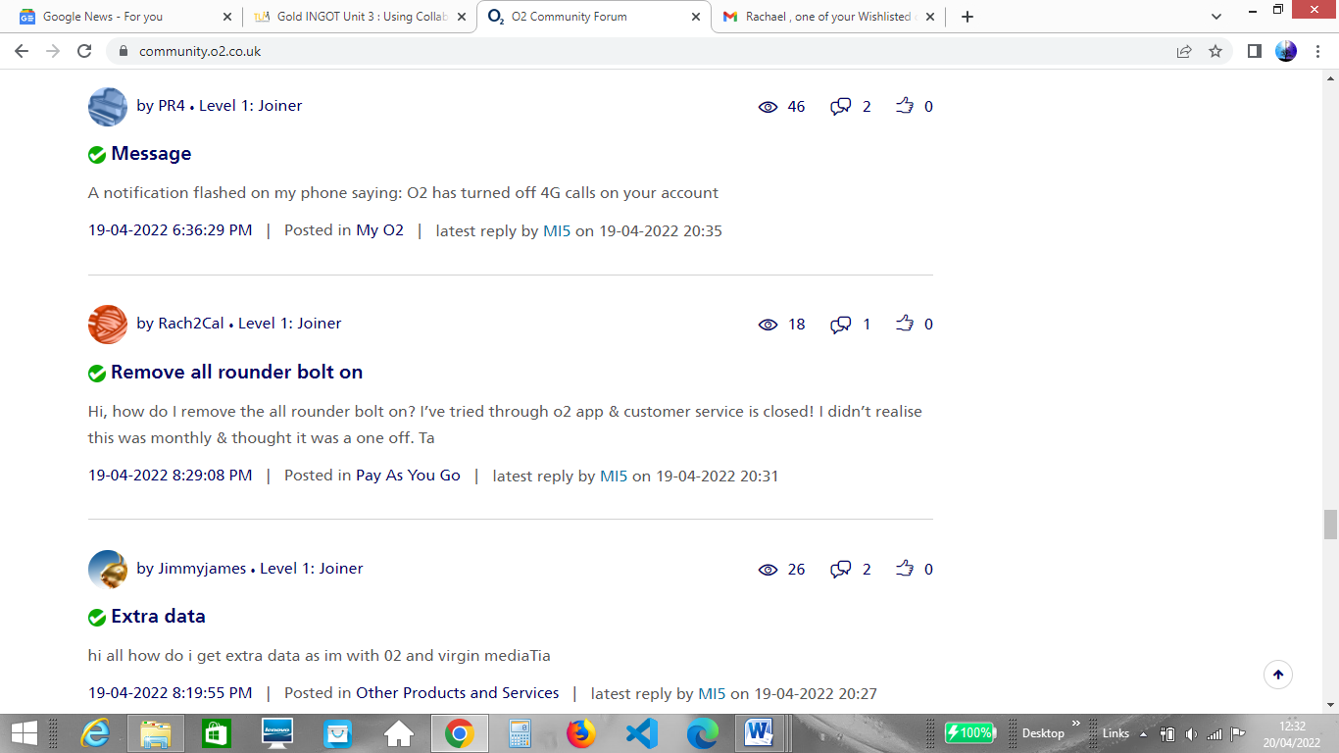

I have followed topics on Google news to help create a news feed that will interest me. I follow Birmingham as a news topic because it is local to me and my feed will update with the latest news related to Birmingham as shown below;

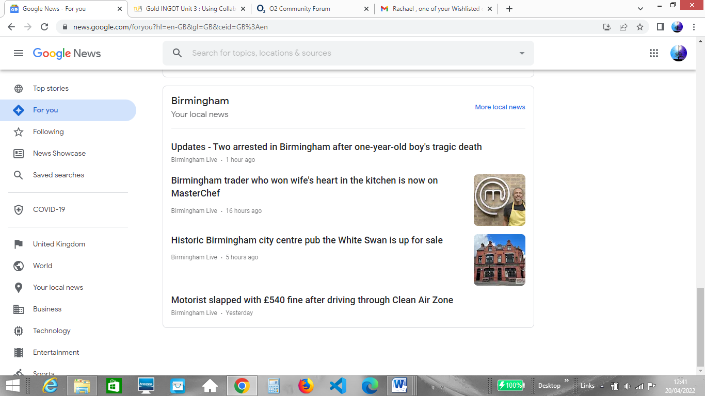

The above is an example of an RSS feed. RSS stands for Really Simple Syndication. An RSS feed is a way for new content from various websites to be published and listed on one page. To create an RSS feed, website publishers create an XML text file on their website that summarizes the latest articles and posts. This is listed in date order, includes a title, brief description and a link to the main content. To read an RSS feed you need to have an RSS reader such as Feedly or Feeder which checks for updates on an RSS feed and then converts the XML files into an easy to read format. XML files (Extensible Mark-up Language) are plain text files which are human and machine readable and are intended to store and transport data.